# Hackathon API Workshop – Pre-workshop Setup

Welcome, workshop participants! So that we can make the best use of everyone’s time, please install the following software and create these accounts before the workshop.

All the software and accounts are free.

You will need to

1. Install Python

2. Install PyCharm Community Edition or another Python IDE of your choice

3. Create a Yelp account and create a Yelp Fusion API key

4. [Optional] Create an IQAir account and create an API key

Details follow.

## 1. Install Python

If you have taken ITEC 1150, you probably have Python installed. If not, or if you have a very old version of Python, install Python from https://www.python.org/downloads/

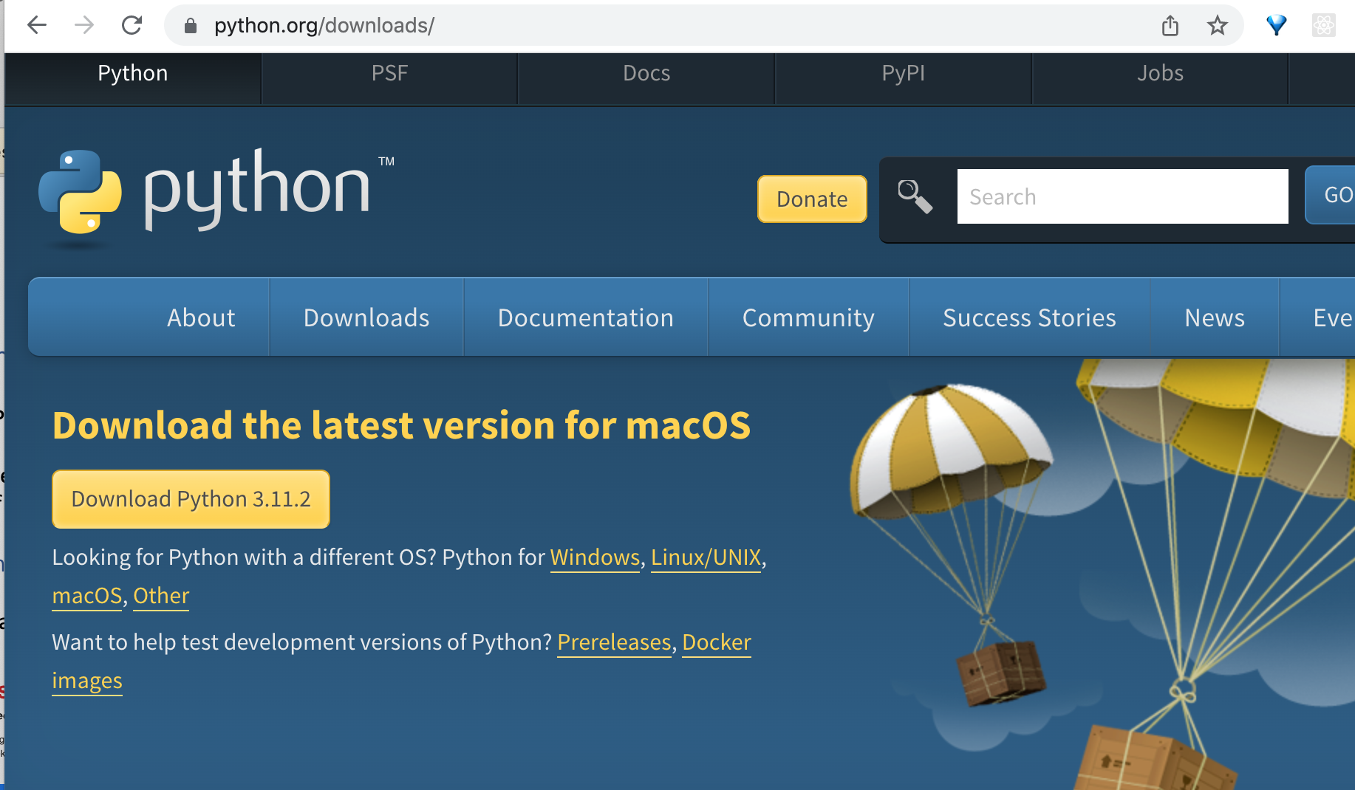

**IMPORTANT NOTE FOR Mac users** – when the installation finishes, a Finder window opens showing the newly installed Python files. You will need to double-click on the **Install Certificates .command** to allow Python to make API requests from your computer.

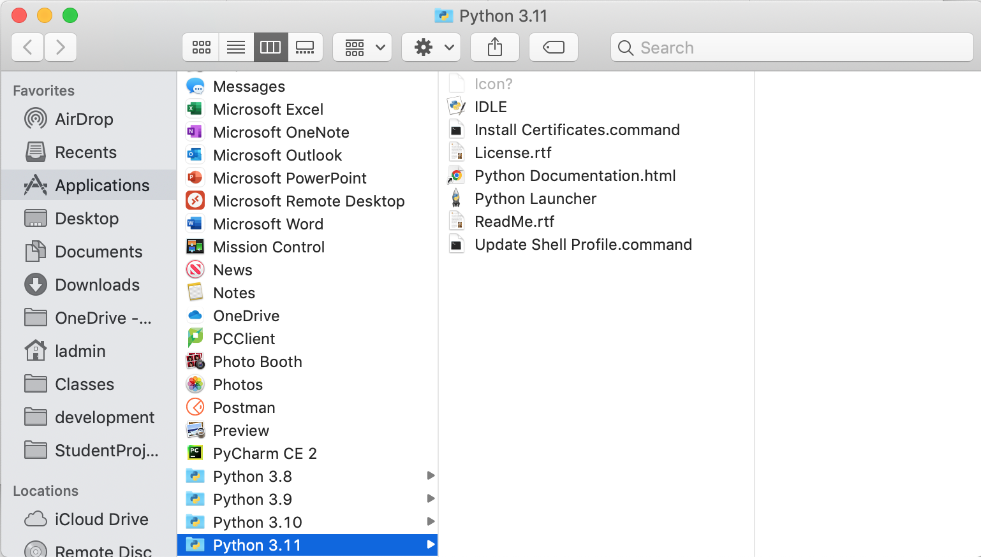

After the command completes, you may close the Finder window.

## 2. Install PyCharm Community Edition, or another Python IDE of your choice

<https://www.jetbrains.com/pycharm/download/>

Click on the black download button to download the free Community edition, then run the installer to install PyCharm.

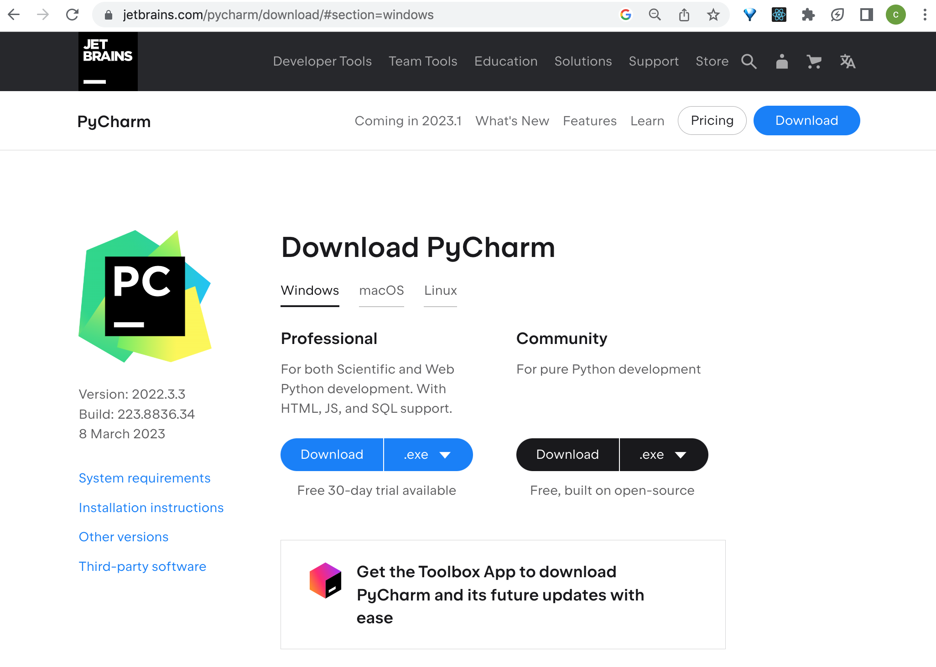

If you already use another Python IDE and know how to install packages, you may use that instead of PyCharm.

## 3. Creating a Yelp developer account

Create a Yelp account at <https://www.yelp.com/signup>

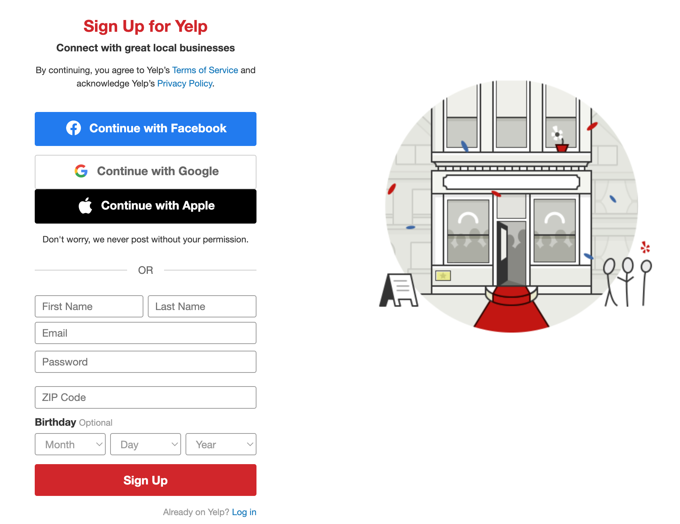

You can click the **Skip** link to skip the photo, phone number etc. and finish creating your account.

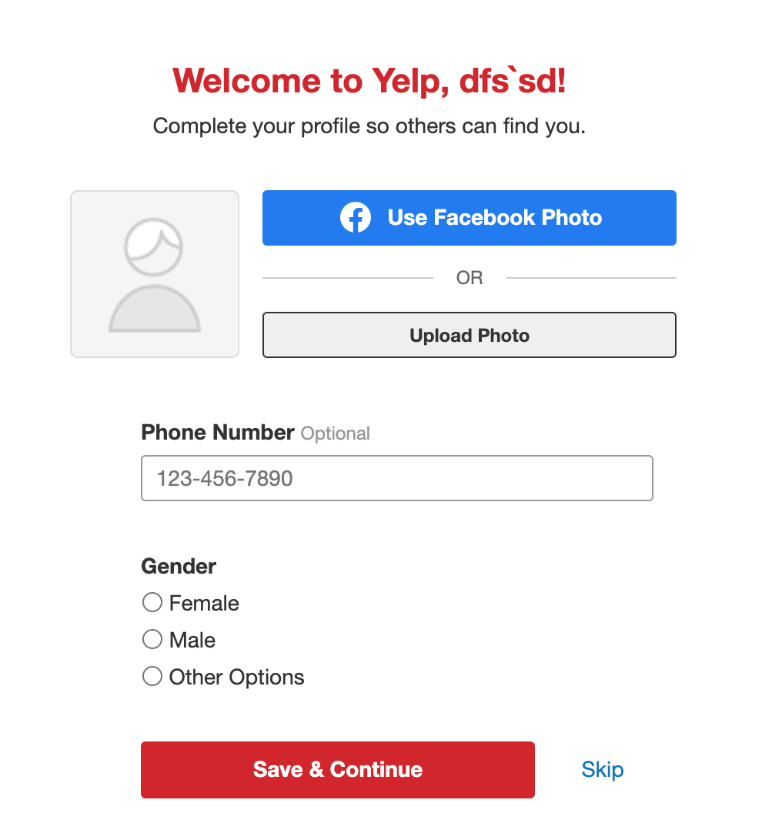

2. Open your email and click on the link in the email Yelp sends you to confirm your email and finish setting up your account.

3. Next, go to <https://fusion.yelp.com/>



Click Manage API access. Sign into your new Yelp account if asked.

You’ll see a Create New App screen. Fill in the form as shown below and click the Create New App button.

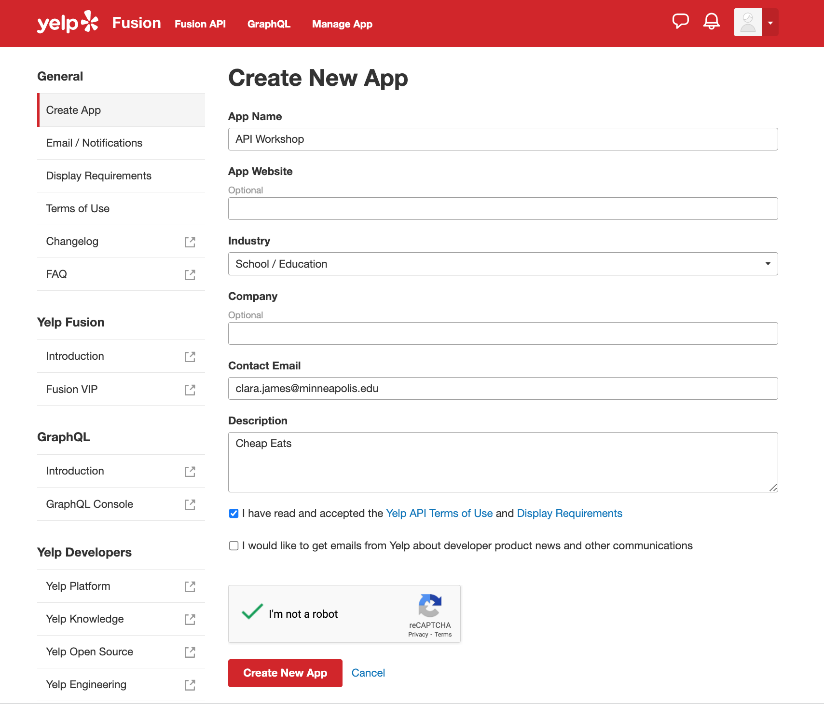

Use your own email here

You’ll see a new screen with your API key. You’ll need this API key to access the API, so make a note of where to find it.

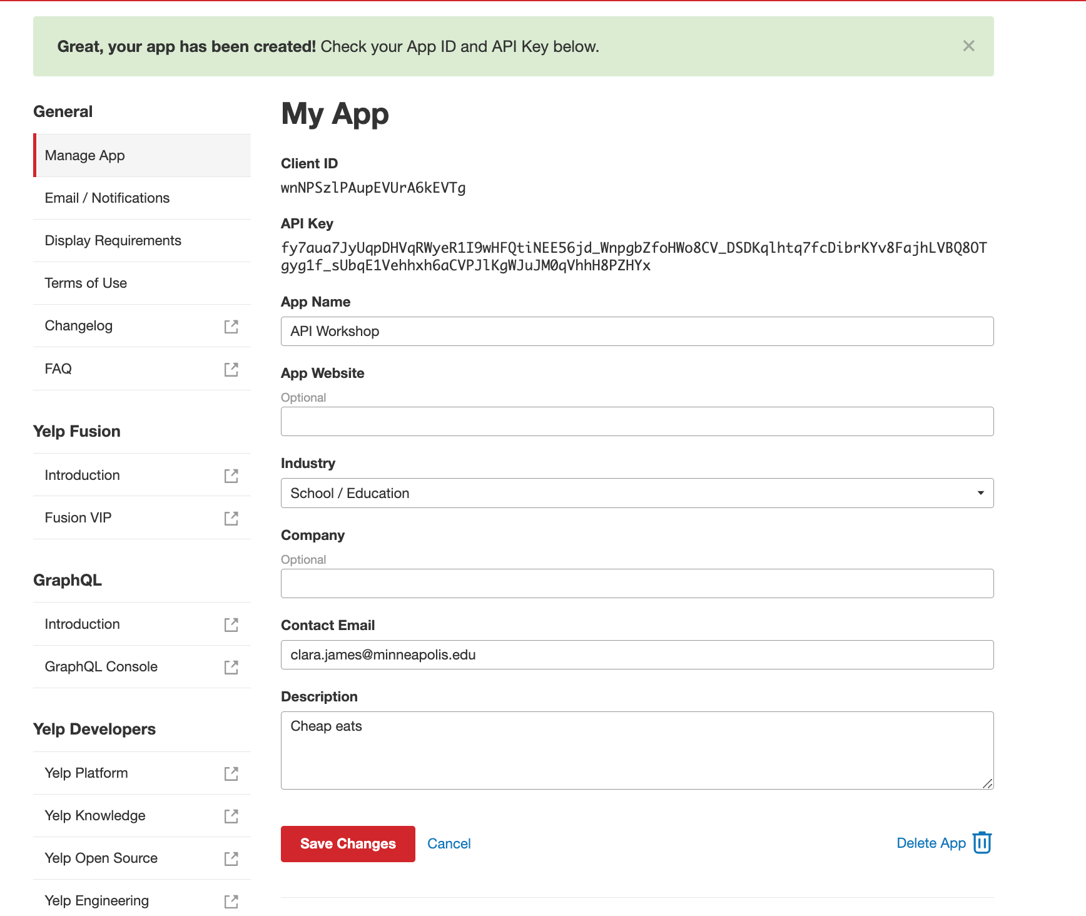

Your API Key

Note that the API documentation is at <https://docs.developer.yelp.com/>

## 4. [Optional] Create an IQAir Account and API key.

1. Go to <https://www.iqair.com/us/air-pollution-data-api> and click Get Started

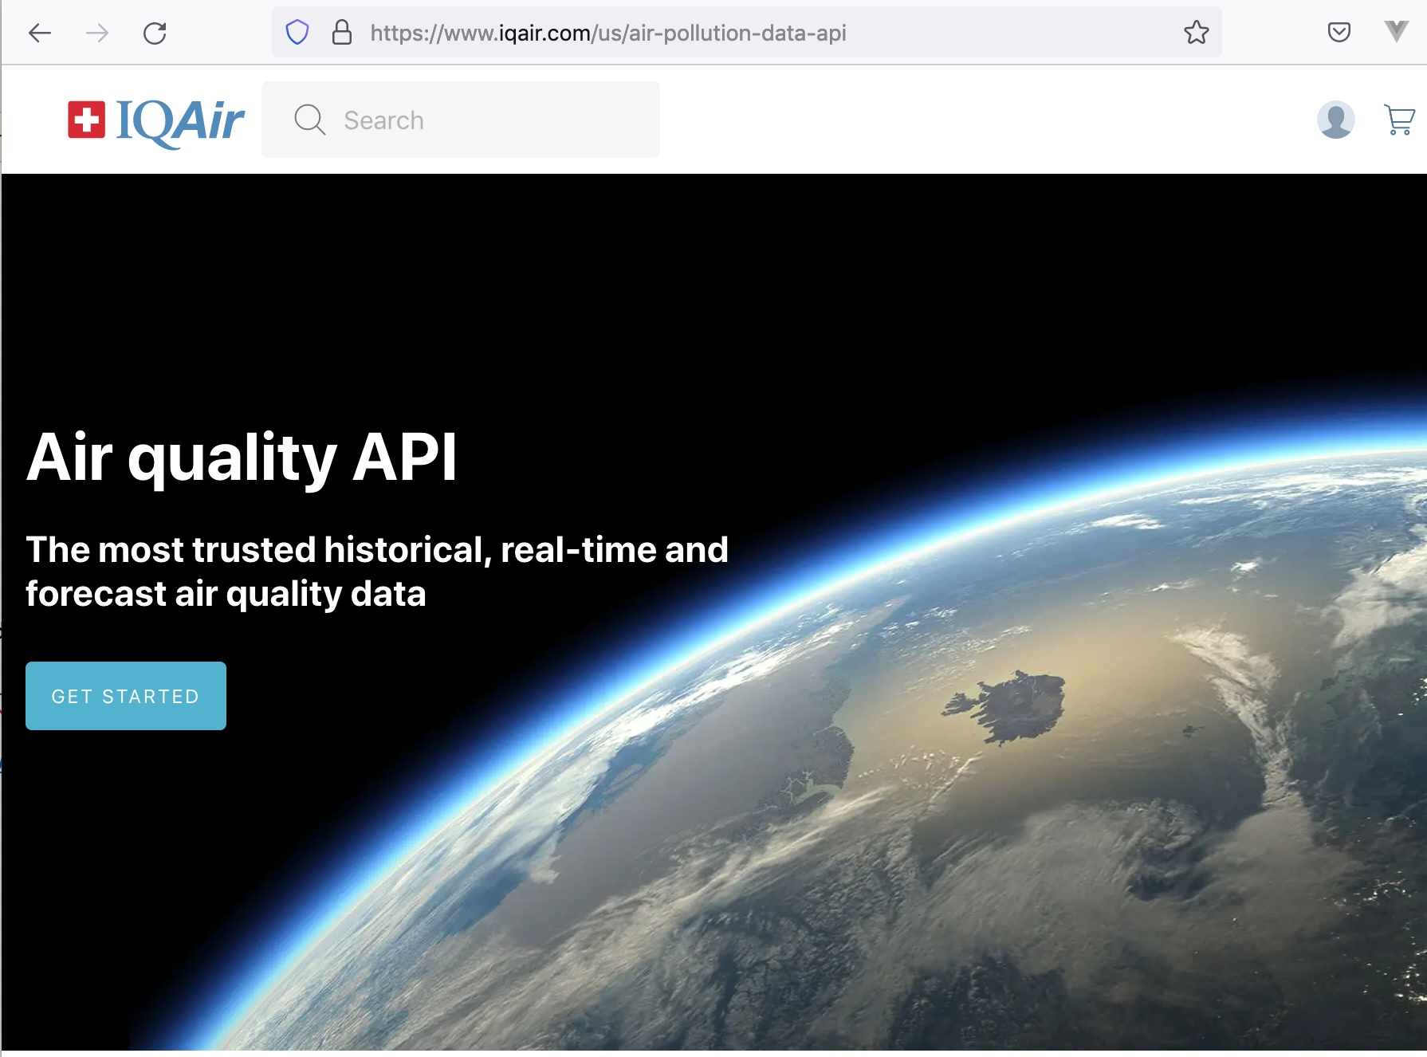

2. Click Start Now in the **Community** Free section,

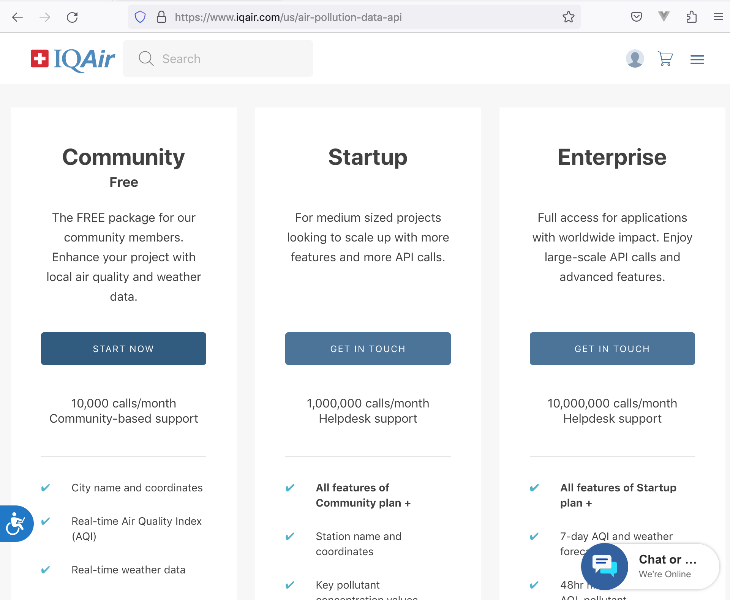

3. Fill out the account registration form

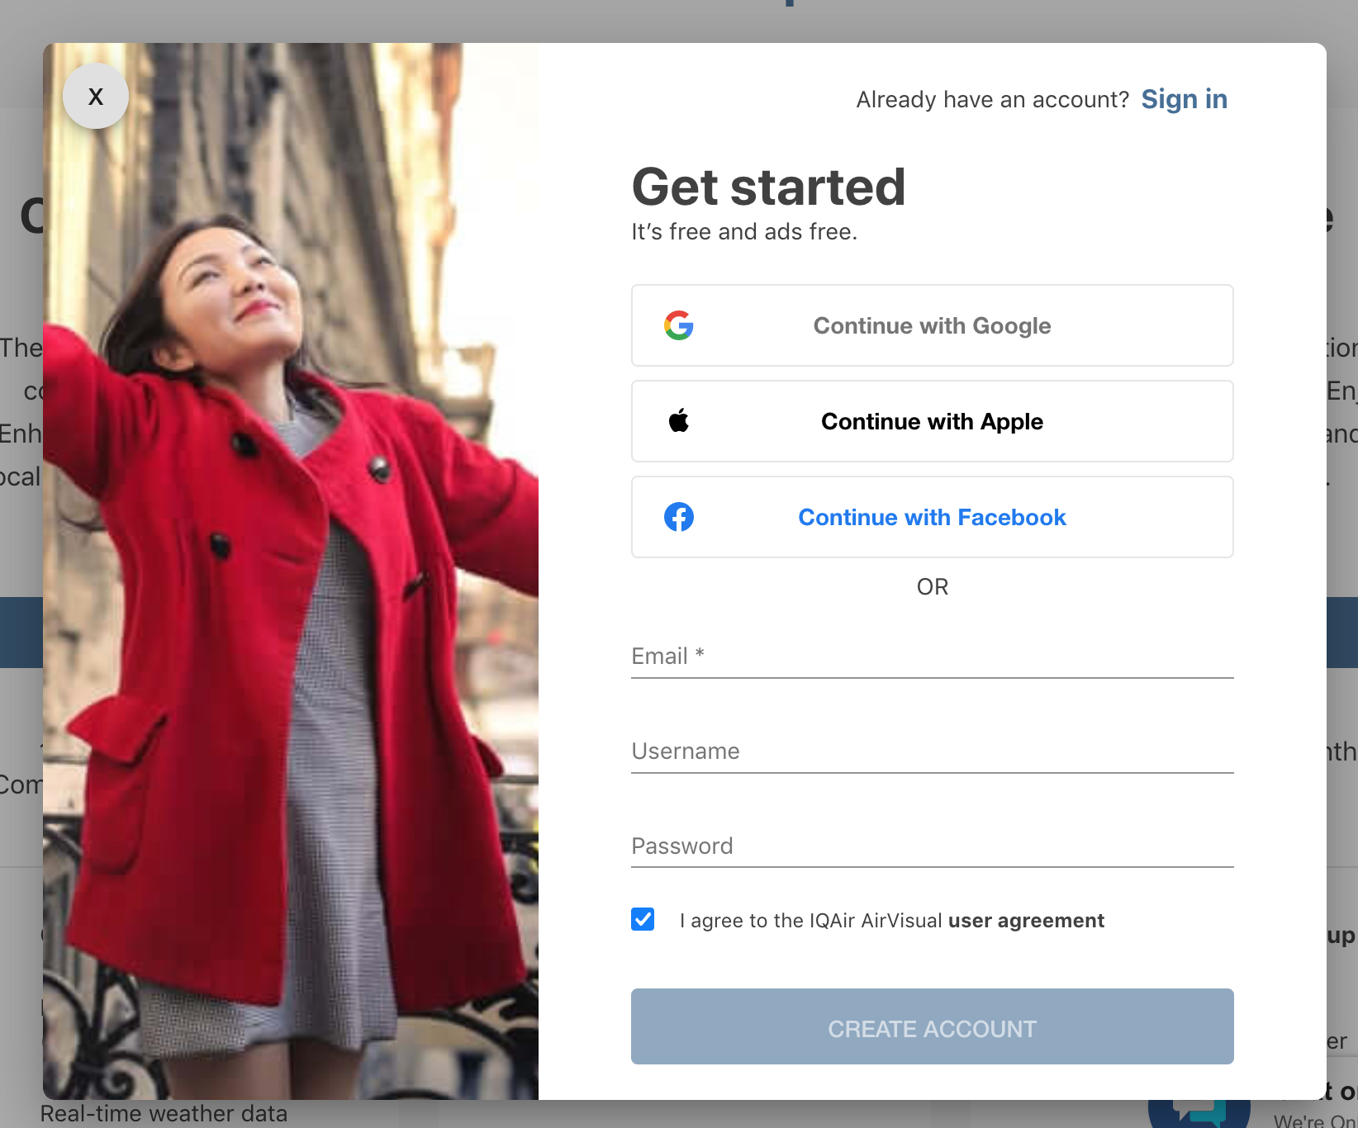

4. Check your email, and click the link to activate your account.

5. Sign into your account

6. Go to the API dashboard at <https://www.iqair.com/us/dashboard/api>

7. Click the New Key button, top right,

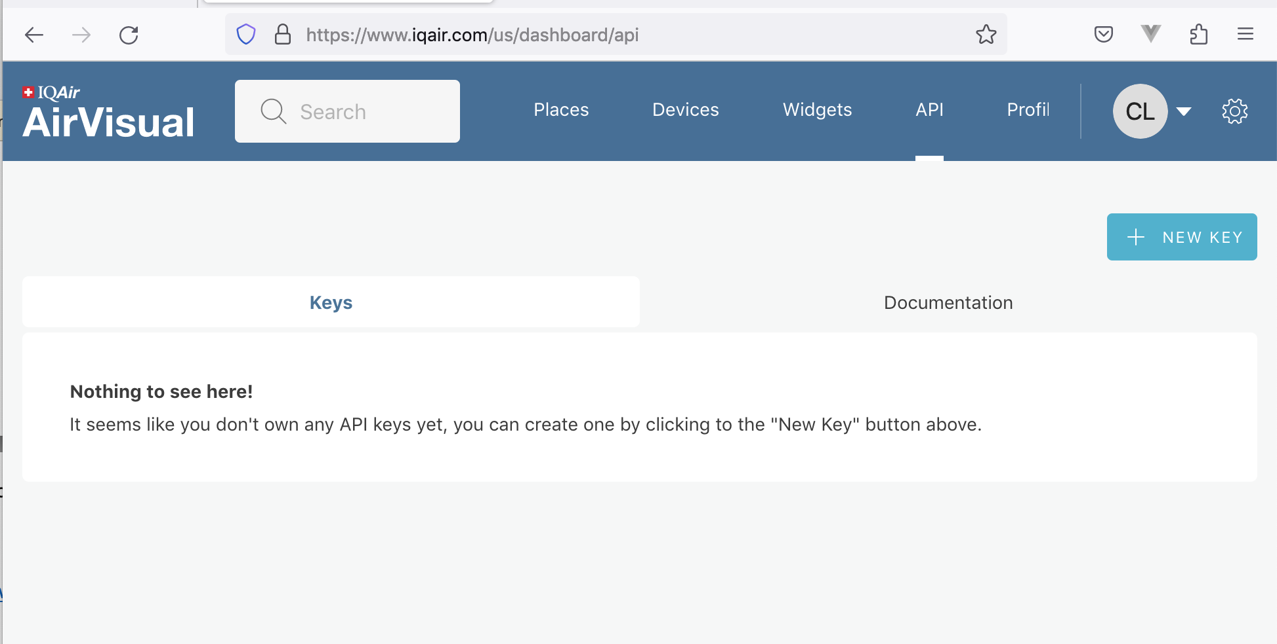

8. Select **Community** for the plan, then click **Create**

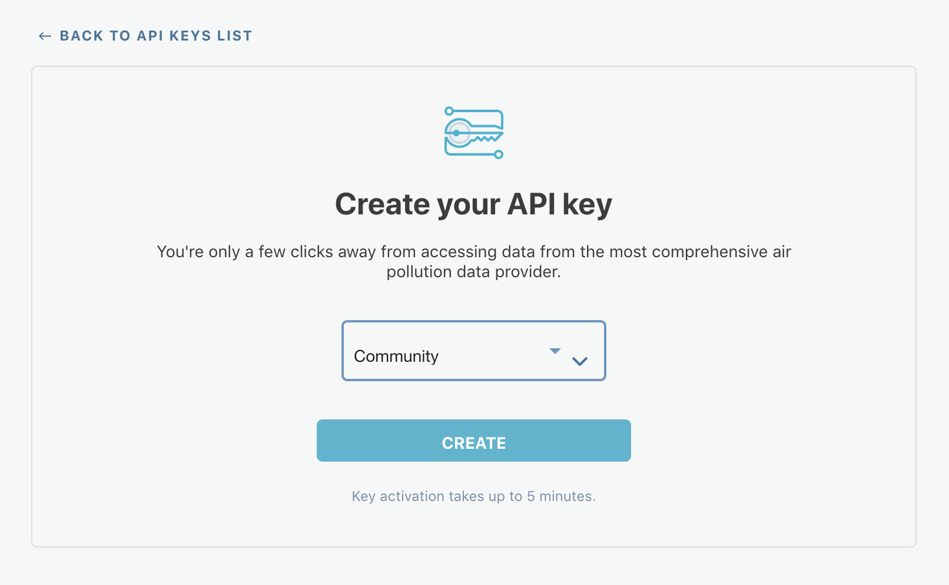

9. Your new key is created. You will need this key for your program, so make a note of the dashboard URL to access the key, <https://www.iqair.com/us/dashboard/api>

